**SECURITY ANALYSIS AND PORTFOLIO MANAGEMENT**

**ANALYSIS OF STOCKS**

Stocks taken for analysis are:

* SBIN
* TITAN
* WIPRO
* RELIANCE
* MARUTI

Benchmark index: NIFTY50

We have collected data from investing.com.

We have calculated the returns of all stocks and market index. Then we have calculated the descriptive statistics of all stocks and nifty50.

Descriptive statistics includes:

* **Mean**: This tells us the average returns.
* **Standard error**: This is the standard deviation of sampling mean distribution.
* **Standard deviation**: This tells us about the risk.
* **Kurtosis**: This tells us about the peak of the normal distribution.
* **Skewness**: It shows biasness for returns.
* **Count**: Total no. of observations taken.

Then we have performed security analysis of each stock.

The security analysis includes:

* **Variance**: It measures the extent of variability of possible returns from the expected returns.
* **Beta**: It is a statistical measure of systematic risk.High Beta price of a security is more responsive to changes in market.Beta for overall market is 1. Beta can be +ve or -ve. Beta generally lies between .4 and 1.9. Beta less than 1 less responsive hence less risky.
* **Alpha**: Alpha is a statistic that measures a portfolio's risk-adjusted returns. A portfolio taking excessive risk and not getting a sufficient return has an alpha of 0 or less. A positive number suggests the portfolio should get a positive return in exchange for the risk level taken.
* **Coefficient of correlation**: Dividing the covariance between two securities by product of standard deviation of each security gives us the coefficient of correlation. The correlation varies from -1 to 1, where -1 indicates perfect negative correlation, 1 indicates perfect positive correlation and values close to 0 indicates that returns are independent.
* **Coefficient of determination**: Tells us that the variability in index return can explain x% of variability in stock return. It’s value ranges from 0 to 1, where 0 means that independent variable cannot be predicted from the independent variable, 1 means the dependent variable can be predicted without error from independent variable, values between 0 and 1 indicates the extent to which the dependent variable is predictable.
* **Systematic risk**: It is the variability in security returns caused by changes in the economy or the market.
* **Unsystematic risk**: The returns from a security may sometimes vary because of certain factors affecting only the company issuing such security. When variability of returns occurs because of such firm-specific factors, it is known as unsystematic risk. By diversifying the portfolio, we can reduce the unsystematic risk.

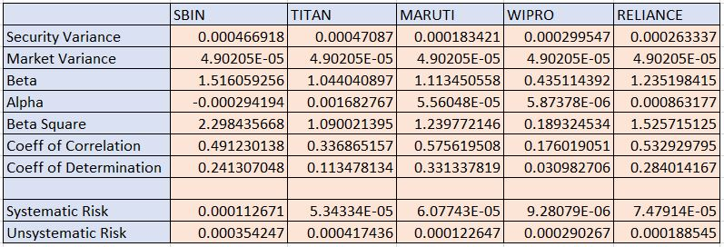



* Beta of SBIN is highest, hence it’s more responsive to changes in the market, thus more risky. Wipro has the least value of beta.
* According to alpha, SBIN is taking excessive risk but is not getting the expected returns.
* According to coefficient of correlation, more positive the value of coefficient of correlation, market will be better correlated with the stock.
* Systematic risk is the risk which can’t be removed by any method. Thus, less the systematic risk better will be the performance of the stock. Here, WIPRO has the least systematic risk while SBIN has the most.
* According to the mean value of returns of the stock, Titan has the highest average return while Wipro has the least average returns.
* According to the standard deviation, Titan has the highest risk while Maruti has the least risk.

From the above observations, Titan will be chosen by the people who are risk lover and Maruti will be chosen by risk averse people.